Mobile-First Design

Definition
# Source: AI Source: Provided by: [Data Path: Persons Table -> ID Column: 1, Name_En Column: Motasem Essam] -> From: [Chatgpt (GPT‑5 Mini)] on [2/12/2026]
Mobile-First Design is a web design technique where a website is designed first for mobile devices, and then expanded to fit larger screens like tablets and desktops.

Simple Definition
# Source: AI Source: Provided by: [Data Path: Persons Table -> ID Column: 1, Name_En Column: Motasem Essam] -> From: [Chatgpt (GPT‑5 Mini)] on [2/12/2026]
Mobile-First Design = designing for small screens first, then adapting to bigger screens.

How Mobile-First Design Works
# Source: AI Source: Provided by: [Data Path: Persons Table -> ID Column: 1, Name_En Column: Motasem Essam] -> From: [Chatgpt (GPT‑5 Mini)] on [2/12/2026]
• Start by designing the layout for mobile devices
• Use simple and clean layouts for small screens
• Gradually add more features and elements for larger screens
• Uses CSS media queries to enhance the design for tablets and desktops

Purpose of Mobile-First Design
# Source: AI Source: Provided by: [Data Path: Persons Table -> ID Column: 1, Name_En Column: Motasem Essam] -> From: [Chatgpt (GPT‑5 Mini)] on [2/12/2026]
• Improve user experience on mobile devices
• Make websites faster and more efficient
• Focus on essential content first
• Ensure better performance on slow networks
• Support the large number of mobile users

Advantages
# Source: AI Source: Provided by: [Data Path: Persons Table -> ID Column: 1, Name_En Column: Motasem Essam] -> From: [Chatgpt (GPT‑5 Mini)] on [2/12/2026]
• Better performance on mobile devices
• Cleaner and simpler design
• Improves loading speed
• Enhances usability and readability
• Helps with SEO (search engine ranking)

Disadvantages
# Source: AI Source: Provided by: [Data Path: Persons Table -> ID Column: 1, Name_En Column: Motasem Essam] -> From: [Chatgpt (GPT‑5 Mini)] on [2/12/2026]
• Can limit creativity due to focusing first on small screens
• Designing for mobile first can make desktop layouts more complex
• Requires careful planning to scale up the design properly
• May take more time to add features for larger screens
• Testing across multiple devices can be time-consuming
• Some advanced features may be harder to implement on mobile first
• Requires strong understanding of responsive design and CSS

Examples
# Source: AI Source: Provided by: [Data Path: Persons Table -> ID Column: 1, Name_En Column: Motasem Essam] -> From: [Chatgpt (GPT‑5 Mini)] on [2/12/2026]
• A website showing only essential content and buttons on mobile
• A simple layout that becomes more complex on desktop
• Navigation simplified into a mobile menu (hamburger menu)

Difference Between Mobile-First Design and Responsive Web Design
# Source: AI Source: Provided by: [Data Path: Persons Table -> ID Column: 1, Name_En Column: Motasem Essam] -> From: [Chatgpt (GPT‑5 Mini)] on [2/12/2026]
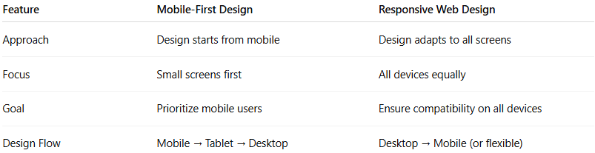
Feature | Mobile-First Design | Responsive Web Design
Approach | Design starts from mobile | Design adapts to all screens
Focus | Small screens first | All devices equally
Goal | Prioritize mobile users | Ensure compatibility on all devices
Design Flow | Mobile → Tablet → Desktop | Desktop → Mobile (or flexible)

